**What is Elastic Load Balancing?**

Elastic Load Balancing automatically distributes your incoming traffic across multiple targets, such as EC2 instances, containers, and IP addresses, in one or more Availability Zones. It monitors the health of its registered targets, and routes traffic only to the healthy targets. Elastic Load Balancing scales your load balancer capacity automatically in response to changes in incoming traffic.

We have below type of Load balancers,

1. Application load balancers
2. Network Load balancers
3. Gateway Load balancers
4. Classic Load balancers – These are the previous generation of load balancers from Elastic load balancing. AWS recommending that you migrate to a current generation load balancer.

Application Load Balancer:  
====================

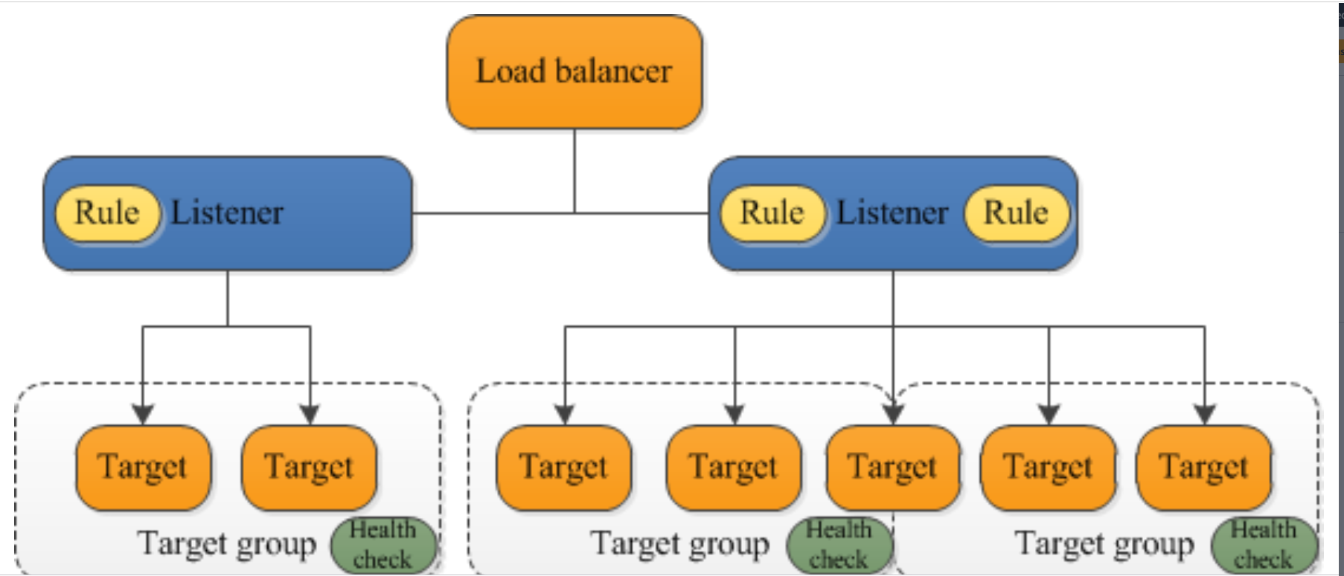

A *listener* checks for connection requests from clients, using the protocol and port that you configure. The rules that you define for a listener determine how the load balancer routes requests to its registered targets. Each rule consists of a priority, one or more actions, and one or more conditions. When the conditions for a rule are met, then its actions are performed. You must define a default rule for each listener, and you can optionally define additional rules.

Each *target group* routes requests to one or more registered targets, such as EC2 instances, using the protocol and port number that you specify. You can register a target with multiple target groups. You can configure health checks on a per target group basis. Health checks are performed on all targets registered to a target group that is specified in a listener rule for your load balancer.

An Application Load Balancer functions at the application layer, the seventh layer of the Open Systems Interconnection (OSI) model. After the load balancer receives a request, it evaluates the listener rules in priority order to determine which rule to apply, and then selects a target from the target group for the rule action. You can configure listener rules to route requests to different target groups based on the content of the application traffic. Routing is performed independently for each target group, even when a target is registered with multiple target groups. You can configure the routing algorithm used at the target group level. The default routing algorithm is round robin; alternatively, you can specify the least outstanding requests routing algorithm.

**Benefits of migrating from a Classic Load Balancer**

1. Support for [Path conditions](https://docs.aws.amazon.com/elasticloadbalancing/latest/application/rule-condition-types.html#path-conditions). You can configure rules for your listener that forward requests based on the URL in the request. This enables you to structure your application as smaller services, and route requests to the correct service based on the content of the URL
2. Support for routing requests to multiple applications on a single EC2 instance. You can register an instance or IP address with multiple target groups, each on a different port.
3. Support for registering Lambda functions as targets.
4. Support for monitoring the health of each service independently, as health checks are defined at the target group level and many CloudWatch metrics are reported at the target group level. Attaching a target group to an Auto Scaling group enables you to scale each service dynamically based on demand.